Basic Architecture for e-commerce website

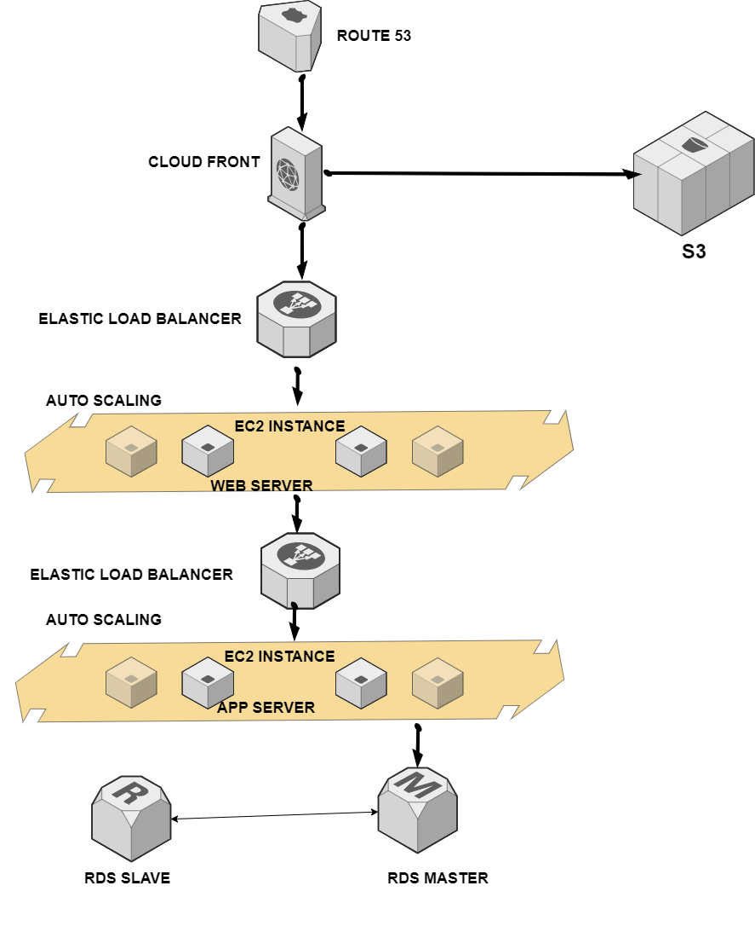

Route 53
A user types in your eCommerce site’s domain name (www.example.com)
CloudFront:
A CDN to deliver content with low latency and high transfer speeds.
Amazon S3
For hosting static website content (HTML, CSS, JavaScript)
Elastic Load Balancer
Incoming traffic from users is directed to the load balancer, which distributes requests evenly among the healthy EC2 instances or containers.
Auto Scaling
During peak shopping seasons (like holidays), Auto Scaling can automatically increase the number of instances to handle the surge in traffic.
Web Server
The web server processes the request, fetching data from a database if needed, and generating a response. Web servers interact with databases to fetch and store dynamic content (like product listings and user data). It serves static files directly (like images) or dynamically generates HTML pages.
App Server
Application servers can be placed behind an Elastic Load Balancer (ELB) to distribute traffic evenly and can scale automatically based on demand using Auto Scaling.
A user interacts with the web frontend of your eCommerce site, triggering a request (e.g., adding an item to the cart). The request is sent to the application server via an API endpoint.
Amazon API Gateway: To create APIs for integrating with payment gateways

Database Layer
Amazon RDS: Managed relational database service (MySQL, PostgreSQL) for transactional data.
Amazon DynamoDB: For NoSQL use cases, such as managing product catalogs and user sessions.
Note: Diagram architect by using an app.diagrams.net
https://drive.google.com/file/d/1XF-mqKM3o6iS499d3_-Y4g5_n6ayOe7W/view?usp=sharing

